Marathwada Shikshan Prasarak Mandal’s

**Deogiri Institute of Engineering and Management Studies,**

**Aurangabad**

**Project Report**

**on**

**Project Name**

Submitted By

**Abhishek Jaju (46035)**

**Pradeep Maku (46034)**

**Vivek Soddy (46039)**

**Dr. Babasaheb Ambedkar Technological University**

**Lonere (M.S.)**



Department of Computer Science and Engineering **(TNR-16)**

**Deogiri Institute of Engineering and Management Studies,**

**Aurangabad**

(2021- 2022)

**Project Report**

**on**

**IPL Score Prediction**

Submitted By

**Abhishek Jaju (46035)**

**Pradeep Maku (46034)**

**Vivek Soddy (46039)**

**In partial fulfillment of**

**Bachelor of Technology**

**(Computer Science & Engineering)**

Guided By

**Prof. Vijay Kolte**

Department of Computer Science & Engineering

**Deogiri Institute of Engineering and Management Studies,**

**Aurangabad**

(2021- 2022)

**CERTIFICATE**

This is to certify that, the Project entitled “**IPL Score Prediction** ” submitted by

**Abhishek Jaju , Pradeep Maku, Vivek Soddy** is a bonafide work completed under my supervision and guidance in partial fulfillment for award of Bachelor of Technology (Computer Science and Engineering) Degree of Dr. Babasaheb Ambedkar Technological University, Lonere.

Place: Aurangabad

Date: 28 January 2022

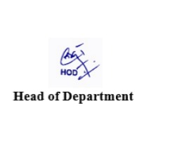

**Mr Vijay Kolte Mr. S.B. Kalyankar**

**Guide Head**



**Dr. Ulhas D. Shiurkar**

**Director**

**Deogiri Institute of Engineering and Management Studies,**

**Aurangabad**

**DECLARATION**

This is to certify that, the partial project report entitled , “IPL Score Prediction” Submitted by Vivek Soddy ,Pradeep Maku ,Abhishek Jaju is a bonafide work completed under my supervision and guidance in partial fulfillment for award of Bachelor degree in Computer Science and Engineering of Deogiri Institute of Engineering and Management Studies, Aurangabad under Dr. Babasaheb Ambedkar Technological University, Lonere.

Place: Aurangabad

Date: 28 January 2022

Prof Vijay Kolte

External Examiner Guide

**Abstract**

Cricket is a popular team sport played internationally. It has tremendous spectator support and the masses show great interest in predicting the outcome of games both in their one-day international as well as the modern T-20 format. The game is governed by complex rules and scoring system. Accurate prediction of winning or losing a match faces significant challenges. Multiple parameters, including cricketing skills and performances, match venues can significantly affect the outcome of a game. These diverse parameters, along with their interdependence and variance create a non-trivial challenge to create an accurate prediction of a game. In this paper, we build a prediction system that takes in historical match data, player performance as well as the scores predicted by spectator, and predicts future match events culminating in a victory or loss. Our system predicts match outcome by analyzing pre-stored match data using simple but effective algorithm. We describe our system and algorithms and finally present quantitative results, demonstrating the performance of our algorithms in predicting the number of runs scored, one of the most important determinants of match outcome. Keywords: Sports prediction, analysis. The cricket in the T-20 format is highly unpredictable - many features contribute to the result of a cricket match, and each attribute feature has a weighted impact on the outcome of a game. In this paper, first, a meaningful dataset through data mining was defined; next, essential features using various methods like feature engineering and Analytic Hierarchy Process were derived. Besides, a key issue on data symmetry and the inability of models to handle it was identified, which extends to all types of classification models that compare two or more classes using similar features for both the classes. This concept in the paper is termed as model ambiguity that occurs due to the model’s asymmetric nature. Alongside, different machine learning classification algorithms like Naïve Bayes, SVM, kNearest Neighbor, Random Forest, Logistic Regression, ExtraTreesClassifier, XGBoost were adopted to train the models for predicting the winner. As per the investigation, tree-based classifiers provided better results with the derived model. The highest accuracy of 60.043% with Random Forest, with a standard deviation of 6.3% and an ambiguity of 1.4%, was observed.

###### Contents

**List of Abbreviations i**

**List of Figures ii**

**List of Graphs iii**

**List of Tables iv**

**List of Screens v**

1. **INTRODUCTION 1** 
   1. Introduction **1**
   2. Necessity **2**
   3. Machine Learning in Sports **5**
   4. Objective  **6**

1. **LITERATURE SURVEY 7**

2.1 Sports and Sports Analytics **7**

2.2 A Multivariate Regression **11**

1. **SYSTEM DEVELOPMENT 18**

3.1 Requirement Specification

3.1.1 DFD (level 1)

3.1.2 Specification Document/UML Diagrams of all modules

3.2 User Interface Design

3.3 Database Design / ER Diagrams

**4.** **PERFORMANCE EVALUATION**

**5. CONCLUSION**

**REFERENCES 23**

**ACKNOWLEDGEMENT**  **24**

**List of Abbreviation**

**Sr.No Acronym Abbreviation**

1 IPL Indian Premier League

**2** KNN  K-Nearest neighbor

**List of Figures**

**Figure Illustration Page**

1.1 Data Flow Diagram 18

1.2 ER diagram 19

1.3 Sequence diagram 20

**List of Graphs**

**Figure Illustration Page**

1.1 _________

1.2 __________

**List of Tables**

**Figure Illustration Page**

1.1 Team Names 17

**List of Screens**

**Figure Illustration Page**

1.1 _________

1.2 __________

**Introduction**

* 1. Introduction

England first introduced T20 Cricket in 2003. Because of its shorter format, it became very popular. Due to its popularity of high voltage action, T20 came to India also. BCCI initiated a 20-20 cricket tournament Indian Premier League (IPL) in 2008. BCCI has been organizing the IPL T20 cricket tournament every year. The use of analytical methods in various aspects of cricket including results prediction is very important. There is a huge demand for the algorithm that best predicts the result of cricket because of its popularity and huge amount of money involved in the game. Thus the analysis of IPL results becomes more important. Prediction of outcome of a match using machine learning algorithms is an important aspect in cricket. Records of the past performance of players and other related data can be analyzed to create models that predicts the winning team. This model can be created using the machine learning algorithms and their results can be compared based on the Evaluation Measures as accuracy, precision, recall, sensitivity and error rate.

As of now, data analysis is need for each and every fields to examine the sets of data to extract the useful information from it and to draw conclusion and as well make decisions according to the information. Data is accessed by the computer programs developed using Machine learning to build models. The algorithm first analyses the data to create a model, specifically for understanding the patterns or trends. For creating the mining model, the model is optimized by selecting parameters and iterating. To extract actionable patterns and detailed statistics, the parameters are then fed into the dataset. This work focuses on finding the meaningful information about the IPL Teams by using the functions of R Package. R reduces the complexity of data analysis as it displays the analysis results in the form of visual representations. The dataset is loaded and a set of pre-processing is done followed by feature selection. Multiple machine learning algorithms are applied and the results are compared to measure the accuracy, precision, recall and sensitivity. The best of the machine learning techniques is then applied to predict the winner and visualizes the results as graphs.

1.2 Necessity

Indian Premier League (IPL) is a professional cricket league

Indian Premier League (IPL) is a professional cricket league based on Twenty20 format and is governed by Board of Control for Cricket in In- dia. The league happens every year with participating teams name representing various cities of India. There are many countries active in organizing Twenty20 cricket leagues. While most of the leagues are being overhyped and team franchises are routinely losing money, IPL has stood out as an exception. As reported by espncricinfo, with Star Sports spending $2.5 billion for exclusive broadcasting rights, the latest season of IPL (2018, 11th) saw 29% increment in the number of viewers including both the digital streaming media and television. The 10th season had 130 million people streaming the league through their digital devices and 410 million people watching directly on the TV . The numbers prove that IPL is a successful Twenty20 format based cricket league.

The amount of data available in today’s world because of technology advancements is seemingly unimaginable. Sports teams are able to use this available data to their advantage. When many people think of sports analysis, the movie “Moneyball” often times comes to mind, but the movie only shows a glimpse what it all entails. The sports industry uses sports analysis to increase revenue, improve player performance and a team’s quality of play, prevent injury and for many more enhancements.

All this data is a great resource; however, it serves no use without people to interpret and analyze how it may be useful. Sports analysts are currently in high demand as many teams are developing entire departments just to analyze statistics, in order to become the best program in the league. In other words, sports teams are using analytics for a competitive advantage. As technology continues to progress, several new developments are expected to emerge in 2018. Three specific advancements include integrating data sources to advance competition, communicate why the data is useful and create a different fan experience. The data is beneficial to many in the industry including coaches, managers, agents, scouts, marketing professionals, medical personnel and the analytics staff.

With the current available technology, sports analysts are able to take data and create insightful yet simple visualizations to communicate to other key decision makers of a team. Many teams use a program called SAS to manage and understand their data. We watched a video addressing the effects the program had on an NBA team, the Orlando Magic. Because of SAS, the Orlando Magic is among the top revenue earners in the NBA, despite being in the 20th-largest market. Many teams are able to see just how much this effected the Magic and thus are encouraged to pay more attention to their analytics department, which may include investing in a resource like SAS.

Other data collecting resources include wearable technology which can be used for many reasons.  One example of this is NFL players wearing devices in their helmets to receive data to help minimize injury. Wearable technology is becoming more and more popular among other teams and leagues to help with injury prevention and player performance. Increasing technology resources are encouraging more leagues to take a closer look at the best resources for analytics to have that competitive advantage teams are looking for.

Another aspect of data analytics in sports is using data to increase revenue and to enhance the fan experience. When ticket sales and attendance are down from the previous seasons, it is the sports analyst job to communicate the numbers and changes from previous seasons.  The chart below shows a few MLB teams and the attendance numbers from the 2001 to 2016 seasons. This is just one example of the data that is collected and analyzed to help increase fan experience and attendance from year to year. I have read several articles that discussed ticket sales, and based on statistics, many sports analysts say that the most influential factor of ticket sales is the wins and losses record of a sport teams. The chart below shows increases and decreases in attendance that change each season, with other available data analysts can determine the probable success each team had the prior season. Sports analysts are able to compare other forms of data with these numbers to determine the biggest cause and further relay the information to sports marketers or other professionals involved in ticket sales and fan experience.

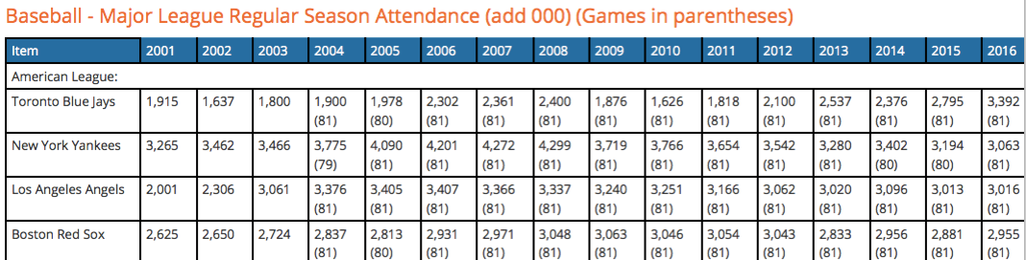

Communicating data efficiently is what sports analytics all comes down to. Without people to analyze and interpret these numbers, they have no meaning to other professionals in the industry. Anyone can create a statistic, but if they are not able to explain the meaning behind how it can help improve the team, then the statistic is useless. Sports analytics are crucial to many teams by helping them become their best through interpretation and analysis of statistics gained in practices and games. As technology and resources are progressing for data collection, sports analytics is a growing field as teams are looking to have a competitive advantage against their opponents. In the technology savvy world, we live in, it only makes sense to use data and sports analytics as an advantage in taking sports teams to a new and improved level.

1.3 Machine Learning in Sports

Various machine learning algorithms have been applied and tested for their eﬃciency in solving the problems in sports. The relation between machine learning and games dates back to the initial days of artiﬁcial intelligence when Arthur Samuel, a pioneer in the ﬁeld of gaming and artiﬁcial intelligence studied machine learning approaches using the game of checkers.

A study was performed to predict the outcome (win, lose or draw) of football matches played by a professional English Premier League (EPL) team, Tottenham Hotspurs, based on matches that were played in the year between 1995 to 1997. It was observed that Bayesian networks relatively outperformed other machine learning algorithms which included MC4 - a decision tree learner, Naive Bayesian learner, Data-driven Bayesian, and K-nearest neighbor. The pre- diction accuracy of the Bayesian nets model was 59.21%. Match outcome prediction and game-play analysis are a prevalent problem that is tackled using machine learning. Another area where machine learning approaches are being used is extracting highlights from an on-going match. A study was performed to extract baseball match highlights on a set-top device. The relative strength of classiﬁcation algorithms, namely Support Vector Machine (SVM), Gaussian Fitting (GAU) and K-Nearest Neighbors (KNN) was considered for ”excited speech” classiﬁcation, and ﬁnally, SVM was applied. Six baseball matches covering 7 hours of game-play time was fed to the algorithm. 75% of the highlights extracted by the algorithm were common with the highlights extracted manually by a human.

Just like in football, supervised machine learning algorithms have also been used in predicting the outcome of baseball matches. A project [27] used two learning methods, i.e., logistic classiﬁcation and Artiﬁcial Neural Network (ANN) to predict the result of the baseball post-season series. Although ANN came up with very poor accuracies, the accuracies out of the logistic model were satisfactory with training and test accuracies of 73.6% and 62.6% respectively. An- other project applied four machine learning algorithms to understand career progression in Baseball [28]. The implemented algorithms were Linear Regression (Ridge Model), Multi-Layer Perceptron Regression (Neural Network), Random Forests Regression (Tree Bagging Model), Support Vector Regression (SVR). The dataset which was used to train these algorithms contained match data of the ﬁrst six seasons of players’ career. And the players’ value were predicted. The prediction was near 60% for the batters, while for pitchers the accuracy was very poor, i.e., something around 30-40%.

1.4 Objective

Cricket is one of the most popular outdoor sports that has captured everyone’s heart. There are many series that are held, and the Indian Premier League (IPL) is one of them which has a long and illustrious tradition in the sports world. IPL is a professional Twenty20 (T20) league started in 2008 which was founded by the Board of Control for Cricket in India (BCCI). The IPL is a 20-over league, which means each team plays 20 overs from both sides. Every year, eight teams from eight Indian cities participate in this league. A cricket match is influenced by a variety of factors, and the factors that have a major impact on the outcome of a T20 cricket match are described in this project. **IPL Score Prediction** project takes several years of IPL data, including player information, match location information, team information, and ball to ball information, and analyzes it to draw different conclusions that help in the enhancement of player’s results. It focuses on calculating the results of IPL matches using data mining techniques on both balanced and imbalanced datasets. In T20 Cricket matches, the first innings score is currently estimated based on the existing run rate, which is measured as the number of runs scored per a number of overs bowled.

**Literature Review**

2.1 Sports and Sports analytics

With technology growing more and more advanced in the last few years, an in-depth acquisition of data has become relatively easy. As a result, Machine Learning is becoming quite a trend in sports analytics because of the availability of live as well as historical data Sports analytics is the process of collecting past matches data and analyzing them to extract the essential knowledge out of it, with a hope that it facilitates in eﬀective decision making. Decision making may be anything including which player to buy during an auction, which player to set on the ﬁeld for tomorrow’s match, or something more strategic task like, building the tactics for forthcoming matches based on players’ previous performances.

Machine Learning can be used eﬀectively over various occasions in sports, both on-the-ﬁeld and oﬀ-the-ﬁeld. When it is about on-the-ﬁeld, machine learn- ing applies to the analysis of a players ﬁtness level, design of oﬀensive tactics, or decide shot selection. It is also used in predicting the performance of a player or a team, or the outcome of a match. On the other hand, the oﬀ-the-ﬁeld scenario concerns the business perspective of the sport , which includes under- standing sales pattern (tickets, merchandise) and assigning prices accordingly. The main focus is the healthy growth in business and proﬁtability of the team owners and other stakeholders. On-the-ﬁeld analytics generally make use of suprevised machine learning algorithms, example: (i) regression for calculating the ﬁtness of a player, (ii) classiﬁcation for predicting an outcome of a match; while oﬀ-the-ﬁeld analytics concerns around performing sentiment analysis to under- stand peoples opinion about a player or a team or a sport league. At present, Twitter has become one of the primary sources of data for sentiment analysis.

Sport Lisboa e Benﬁca, one of Portugals most successful football clubs advancing in the use of data modeling techniques while making decisions is one real-world example of the use of machine learning in sports science. The club monitors and analyzes almost every aspect of a player, including their sleeping, eating, training habits. Once raw player data is recorded, various models are designed to analyze the data for optimizing match readiness and deﬁning personalized practice schedules. With the application of machine learning and predictive analysis, the facts coming out of the devised models enable players to improve their performance continually. On the other cards, with those facts at hand, manager/coach gets a better idea about which player to be replaced, which player to be kept in the playing list and which player to be kept in the bench.

Major League Baseball (MLB) has seen enormous growth in the arena of sports analytics in the last few years . Professional MLB teams collect tremendous amount of ball-by-ball data and apply various machine learning approaches to get clear insights into the game, which is usually not visible through human analysis. Predicting the outcome of a match, classifying if a team will intentionally make a player walk at bat or classifying non-fastball pitches according to pitch type, etc. are some of the classiﬁcation problems dealt using machine learning in baseball world

Similarly, cricket has also been making use of sports analytics to perform prediction of outcome of a match, while the gameplay is in progress or before the match has even begun . Even problem like predicting runs or wickets of a player for a match, based on his/her past performance is an interesting problem to work on. Some real-world tools which have been implemented in cricket include WASP (Winning and Score Predictor) a tool which predicts a score and possible outcome of a limited over cricket match, i.e., One-day or Twenty20. Sky Sports New Zealand ﬁrst introduced this tool in 2012 during an ongoing Twenty20 match. Technology like Hawk-Eye which tracks the trajectory of a ball and visually displays the most statistically signiﬁcant path, has also been oﬃcially in use as the Umpire Decision Review System since 2009. Similarly, other sports like tennis, badminton, snooker also make use of this computer-assisted intelligent technology.

In cricket, to predict an outcome of a match, the primary task is to extract out the essentials factors (features) which aﬀect result of a match. Interesting works have been done in the ﬁeld of predicting outcome in cricket. Some interesting machine learning works have been performed on data acquired from Indian Premier League matches. In a study , the Naive Bayesian classiﬁer was used to classify the performance of all-rounder players (bowler plus batsman) into four various non-overlapping categories, viz., a performer, a batting all-rounder, a bowling all- rounder or an underperformer by being based on their strike rate and economy rate. Step-wise multinomial logistic regression (SMLR) was used to extract the essential predictors. When validated, the Naive Bayesian model was able to classify 66.7% of the all-rounders correctly. The same authors later published a work in which an Artiﬁcial Neural Network model was used to predict the performance of bowlers based on their performance in the ﬁrst three seasons of IPL . When the predicted results were validated with actual performance of the players in season four, the developed ANN model had an accuracy of 71.43%. Although not related to IPL, a study performed at University College London in the area of predicting the outcome of a Twenty20 match would be a healthy addition as the literature work in the Twenty20 domain. The study made use of Naive Bayes, Logistic Regression, Random Forests, Gradient Boosting algorithms to predict the outcome of English County cricket matches. Two models were developed, each was given input of two diﬀerent sets of features. The team only related features were input to the ﬁrst model, while team and players related features were input to the second model. The study was concluded with Naive Bayes outperforming all other algorithms with the ﬁrst model giving out average prediction accuracy of 62.4% and second model giving average prediction accuracy of 63.9%, i.e., 64% average accuracy with 2009-2014 data and 63.8% average accuracy with 2010-2014 data.

The work done on Data Mining of Cricket dataset describes the various data mining techniques applied on the IPL dataset, the model is built for predicting the results of the matches. The selection of the best team is always required by the management for best outcome. The paper provides the optimal solution to select the best team using Data Mining Techniques rather than following the traditional method which is tedious. When we are declaring a time for the particular championship it is mandatory to select the best team and so the chance of the team to be the champion becomes easy.

In previous work the authors proposes the fuzzy clustering logic. The results of the IPL batting Statistics were grouped into various clusters and it gave efficient and effective accurate results with the Data Mining Technique – Clustering. This work has been done with the help of MATLAB. The concept of clustering is used in order to classify batting statistics of the Indian Premier League which has the fuzzy data into appropriate clusters.

Raza Ul Mustafa et al presented a study on the investigation of the feasibility of using the Twitter data to forecast the results of the match. The work has been proposed to check the machine learning techniques’ effectiveness when applied on data collected to derive insight obtained from social media networks and other real world events are predicted. The techniques used in their work are Support Vector Machine, Naive Bayes Classifier and the Linear Regression. The SVM technique holds good.

Live Cricket Score and Winning Prediction work describes about the building of the model which predicts the score for the chasing team and will estimate the score of the second innings of match. The proposed work uses the concepts of Linear Regression, Naive Bayes Classifier and Reinforce Learning Algorithm and gives the idea about building a system of prediction that takes the historical data and predicts the victory or loss of the forthcoming matches.

The work done on Data Mining of Cricket dataset describes the various data mining techniques viz Decision Tree, Naive Bayes, KNN, Random Forest applied on the IPL dataset, the model is built for predicting the results of the matches. The best attributes were selected using the Wrapper and Ranker method and then the classification has been done. This work was done with the help of WEKA. Gupta et al. says that the selection of the best team is always required by the management for best outcome. The paper provides the optimal solution to select the best team using Data Mining Techniques rather than following the traditional method which is tedious. When we are declaring a time for the particular championship it is mandatory to select the best team and so the chance of the team to be the champion becomes easy. In , the authors proposes the fuzzy clustering logic. The results of the IPL batting Statistics were grouped into various clusters and it gave efficient and effective accurate results with the Data Mining Technique – Clustering. This work has been done with the help of MATLAB. The concept of clustering is used in order to classify batting statistics of the Indian Premier League which has the fuzzy data into appropriate clusters.

Raza Ul Mustafa et al presented a study on the investigation of the feasibility of using the Twitter data to forecast the results of the match. The work has been proposed to check the machine learning techniques’ effectiveness when applied on data collected to derive insight obtained from social media networks and other real world events are predicted. The techniques used in their work are Support Vector Machine, Naive Bayes Classifier and the Linear Regression. The SVM technique holds good. Live Cricket Score and Winning Prediction work describes about the building of the model which predicts the score for the chasing team and will estimate the score of the second innings of match. The proposed work uses the concepts of Linear Regression, Naive Bayes Classifier and Reinforce Learning Algorithm. The factors such as toss result, ranking of the team, home team advantage were considered. Sankaranarayanan gives the idea about building a system of prediction that takes the historical data and predicts the victory or loss of the forthcoming matches.

They used Linear Regression, Nearest Neighboring and clustering methods will present the mathematical results will exhibit the performance of the algorithm for predicting the results of the model. Parag Shah, in his work of predicting outcome of the live match proposed model which predict the match result after each ball. The par score concept has been used Duckworth & Lewis, the probability is calculated and it provides clarity of who will win the match

Kaluarachchi used artificial intelligent technique specifically bayes classifiers in machine learning to classify the factors as home game advantage, day/night effect the toss and batting first that affects the result of the match. The final outcome of this work is the delivered as software tool called CricAI. The tool gives the probability of winning based on the input factors such as home game advantage is available at the beginning of the match. The CricA1 can be used in real-world applications when teams are playing cricket. It is used for modifying certain factors to increase the chances of winning in the real field. The models use Data Analytics methods from machine learning domain. In a rain affected match the prediction of the result may be difficult .In a rain affected match Batting, Bowling, Fielding, Team Selection, Result Prediction, Target Revision is very important. The match prediction can be solved using the mathematical model created based on the insights of the results of prior matches. The Predictor models are created with the help of SVM. This work is proposed using Deep Mayo Predictor

The software developed based on the work by Jayshree Hajgude for Statistical Analysis and Data Mining forms a dream team with the Bayesian Prediction Technique and Parameter based filtering. The database has the details of the current IPL players. This work helps to mine the needed data for using by prediction algorithm in order to obtain the statistical analysis of each player. Predictive model is developed to predict the cricket score and player performance using ODI dataset . Performed Supervised methods like SVM, Naïve Bayes. Clustering methods like KNN and MLP method to classify accurately. The work done by Kaluarachchi used artificial intelligent technique specifically bayes classifiers in machine learning to classify the factors as home game advantage, day/night effect the toss and batting first that affects the result of the match. The final outcome of this work is the delivered as software tool called CricAI. The tool gives the probability of winning based on the input factors such as home game advantage is available at the beginning of the match. The CricA1 can be used in real-world applications when teams are playing cricket. It is used for modifying certain factors to increase the chances of winning in the real field

The models use data analytics methods from machine learning domain. In a rain affected match the prediction of the result may be difficult. In a rain affected match batting, bowling, fielding, team selection, result prediction, target revision is very important. The match prediction can be solved using the mathematical model created based on the insights of the results of prior matches. The Predictor models are created with the help of SVM. This work has been proposed using Deep Mayo Predictor .

The software developed based on the work by Hajgude for Statistical Analysis and Data Mining forms a dream team with the Bayesian Prediction Technique and Parameter based filtering. The database has the details of the current IPL players. This work helps to mine the needed data for using by prediction algorithm in order to obtain the statistical analysis of each player. Predictive model is developed to predict the cricket score and player performance using ODI dataset Performed Supervised methods like SVM, Naïve Bayes. Clustering methods like KNN and MLP method to classify accurately. IPL match winner prediction is carried out using ML techniques . IPL is interesting game each year there is lot of expectations of who will win the prestigious title. IPL is game where the result can be changed in just few seconds so to predict the winner ML algorithms like SVM, Logistic Regression, Naïve Bayes, Decision Tree and KNN. To overcome these existing modules, we developed a predictive technique for predicting the winning team

2.2 A Multivariate Regression approach

The literature survey concluded that there was a need for a machine learning model which could predict the outcome of an IPL match before the game begins. Among all formats of cricket, Twenty20 format sees a lot of turnarounds in the momentum of the game. An over can completely change a game. Hence, predicting an outcome for a Twenty20 game is quite a challenging task. Besides, developing a prediction model for a league which is wholly based on auction is another hurdle. IPL matches cannot be predicted simply by making use of statistics over historical data solely. Because of players going under auctions, the players are bound to change their teams; which is why the ongoing performance of every player must be taken into consideration while developing a prediction model.

In sports, most of the prediction job is done using regression or classiﬁcation tasks, both of which come under supervised learning. In simple terms, y=f(x)

is a prediction model which is learned by the learning algorithm from a set of dataset: D= ((X1, y1),(X2, y2),(X3, y3), ...(Xn, yn)). Based on the type of output (y) supervised learning is divided further into two categories, viz., regression, and classiﬁcation. In Regression, the output is a continuous value; however, clas siﬁcation deals with discrete kind of output. For predicting continuous values, Linear Regression appeared to be quite eﬀective, and for classiﬁcation problems like predicting the outcome of matches or classifying players, learning algorithms like Naive Bayes, Logistic Regression, Neural Networks, Random Forests were found being used in most of the previous studies

In this work, the various factors that aﬀect the outcome of a cricket match were analyzed, and it was observed that home team, away team, venue, toss winner, toss decision, home team weight, away team weight, inﬂuence the win probability of a team. The proposed prediction model makes use of multivariate Regression to calculate points of each player in the league and compute the overall strength of each team based on the past performance of the players who have appeared most for the team

**2.2.1 Dataset**

Dataset The oﬃcial website of Indian Premier League [35] was the primary

The oﬃcial website of Indian Premier League was the primary source of data for this study. The data was scraped from the site and maintained in a Comma Separated Values (CSV) format. The initial dataset had many features including date, season, home team, away team, toss winner, man of the match, venue, umpires, referee, home team score, away team score, power play score, overs details when team reached milestone of multiple of 50 (i.e., 50 runs, 100 runs, 150runs), playing 11 players, winner and won by details. In a single season, a team has to play with other teams in two occasions, i.e., once as a home team and next time as an away team. For example, once KKR plays with CSK in its home stadium (Eden Gardens) next time they play against CSK in their home stadium (M Chinnaswamy Stadium). So, while making the dataset, the concept of home team and away team was considered to prevent the redundancy.

Indian Premier League has just been 11 years old, which is why only 634 matches data were available after the pre-processing. This number is considerably less with comparison to the data available relating to the test or ODI formats. Due to certain diﬃculties with some ongoing team franchises, in some seasons the league has seen the participation of new teams, and some teams have discontinued. Presence of those inactive teams in the dataset was not really necessary, but if the matches data were omitted where the inactive teams appeared, the chances were that the valuable knowledge about the teams which were still active in the league would deteriorate. For better understanding and to make the dataset look somehow cluttered-free, acronyms were used for the teams. Table 1 lists the acronyms used in the dataset.

There are various ways a player can be

There are various ways a player can be awarded points for their performance in the ﬁeld. The oﬃcial website of IPL has a Player Points section where every player is awarded points based on these 6 features: (i) number of wickets taken, (ii) number of dot balls given, (iii) number of fours, (iv) number of sixes, (v) number of catches, and (vi) number of stampings. To ﬁnd out how IPL management was assigning points to each player based on these 6 features, a multivariate regression was used on the players’ points data. Freedman [36] has beautifully explained the mathematics behind the Regression models.

For a team, there can be as many as 25 players. This

For a team, there can be as many as 25 players. This

For a team, there can be as many as 25 players. This is a limit put on by IPL governing council to the franchises. To ﬁnd the average strength of a team, every player of the team is ﬁrst sorted in the descending order according to their number of appearances in previous matches of the same season. Once players have been sorted, the top 11 players are considered for calculating the weight of the team because these players have played more games for the team and their performance inﬂuence the overall team strength. Figuring team weight for all 634 matches was a tedious task. So, for example purpose, the ﬁnal results of each season were considered, and the team weight for each team was calculated accordingly, and the same score was used for all the matches in that particular season. For better performance of the classiﬁer, the team weight must be calculated immediately after the end of each match. This way, the real-time performance of each team and the newly computed weight can be used in predicting upcoming games.

In this study, Recursive Feature Elimination (RFE) algorithm was used as a feature selection method. As the name suggests, RFE recursively removes an unessential feature from a set of features, re-builds the model using the remaining features and recalculates the accuracy of the model. The process goes on for all the features in the dataset. Once completed, RFE comes up with top k number of features which inﬂuence the target variable (independent variable) at a level of extent. Sometimes, ranking the features and using the top k features for building a model might result in wrong conclusions To prevent this from happening, the dataset was resampled, and RFE was operated in the subsets. The results were the same set of features obtained initially; hence, the initial set of features obtained from RFE did not seem to be biased. Using the RFE model, the number of features was reduced to 7. Thus obtained features which highly inﬂuenced the target variable were the home team, the away team, the venue, the toss winner, toss decision, and the respective teams’ weight.

**2.2.2 Conclusion**

In this study, the various factors that inﬂuence the outcome of an Indian Premier League matches were identiﬁed. The seven factors which signiﬁcantly inﬂuence the result of an IPL match include the home team, the away team, the toss winner, toss decision, the stadium, and the respective teams’ weight. A multi variate regression based model was formulated to calculate the points earned by each player based on their past performances which include (i) number of wickets taken, (ii) number of dot balls given, (iii) number of fours hit, (iv) number of sixes hit, (v) number of catches, and (vi) number of stumpings. The points awarded to each player was used to compute the relative strength of each team. Various classiﬁcation-based machine learning algorithms were trained on the IPL dataset designed for this study. The dataset contained all the match data since the beginning of Indian Premier League till 2017. The trained models were used to predict the outcome of each 2018 IPL match, 15 minutes before the game-play, immediately after the toss. The Multilayer perceptron classiﬁer outperformed other classiﬁers by correctly predicting 43 out of 60, 2018 Indian Premier League matches. The accuracy of the MLP classiﬁer would have improved further if the team weight was calculated immediately after the end of each match. Because this is the only way, the classiﬁer gets fed with real-time performance of the participating teams.

The Twenty20 format of cricket carries a lot of randomness, because a single over can completely change the ongoing pace of the game. Indian Premier League is still at infantry stage, it is just a decade old league and has way less number of matches compared to test and one-day international formats. Hence, designing a machine learning model for predicting the match outcome of an auction-based Twenty20 format premier league with an accuracy of 72.66% and F1 score of 0.72 is highly satisfactory at this stage

n this study, Recursive Feature Elimination (RFE) al-

Team names and their acronym

|  |  |
| --- | --- |
| Team Name | Acronym |
| Chennai Super Kings | CSK |
| Delhi Daredevils | DD |
| Kings XI Punjab | KXIP |
| Kolkata Knight Riders | KKR |
| Mumbai Indians | MI |
| Rajasthan Royals | RR |
| Royal Challenger Bangalore | RCB |
| Sunrisers Hyderabad | SRH |
| Rising Pune Supergiant | RPS* |
| Deccan Chargers | DC* |
| Pune Warriors India | PWI* |
| Gujrat Lions | GL* |
| Kochi Tuskers Kerala | KTK* |

Table 1.1

*Inactive teams as of 2018 AD

**3 .SYSTEM DEVELOPMENT**

3.1. Requirement Specification

System Features and Requirements

Functional Requirements

* It should provide schedule without any of clashes among IPL teams, day, time and stadiums that must be visible to all.
* It should generate a report about the registered complaint to the admin and response report to the user who has submitted his queries.
* Secure registration and profile management facilities for different users.
* It should provide detailed guide on software installation and using procedure to users.
* It should generate and notify alerts via SMS and E-mail.

Non- Functional Requirements

1) Safety Requirements

If there is extensive damage to a wide portion of the database due to catastrophic failure, such as a disk crash, the recovery method restores a past copy of the database that was backed up to archival storage (typically tape) and reconstructs a more current state by reapplying or redoing the operations of committed transactions from the backed up log, up to the time of failure.

2) Security Requirements

Security systems need database storage just like many other applications. However, the special requirements of the security market mean that vendors must choose their database partner carefully.

3) Software Quality Attributes

* AVAILABILITY: Since we are hosting our project on the server it will be available all the time.
* CORRECTNESS: The system should generate an appropriate report about different activities of the IPL season and should keep track of all records.
* MAINTAINABILITY: The system should maintain correct schedules of date, match and timings of all matches.
* USABILITY: The system should satisfy the maximum number of user’s needs.

Software Requirements:

* Flask==1.1.1
* gunicorn==19.9.0
* itsdangerous==1.1.0
* Jinja2==2.10.1
* MarkupSafe==1.1.1
* Werkzeug==0.15.5
* numpy>=1.9.2
* scipy>=0.15.1
* scikit-learn>=0.18
* matplotlib>=1.4.3
* pandas>=0.19

Hardware Requirement

* 1GHz+ CPU.
* 512MB RAM.
* 20MB database space.
* 300MB disk space

**3.1.1** DFD Diagram

Data flow diagram (DFD) maps out the flow of information for any process or system. It uses defined symbols like rectangles, circles and arrows, plus short text labels, to show data inputs, outputs, storage points and the routes between each destination. Data flowcharts can range from simple, even hand-drawn process overviews, to in-depth, multi-level DFDs that dig progressively deeper into how the data is handled. They can be used to analyze an existing system or model a new one. Like all the best diagrams and charts, a DFD can often visually “say” things that would be hard to explain in words, and they work for both technical and nontechnical audiences, from developer to CEO. That’s why DFDs remain so popular after all these years. This DFD diagram is an overview of the process, data store and data flow in the project.

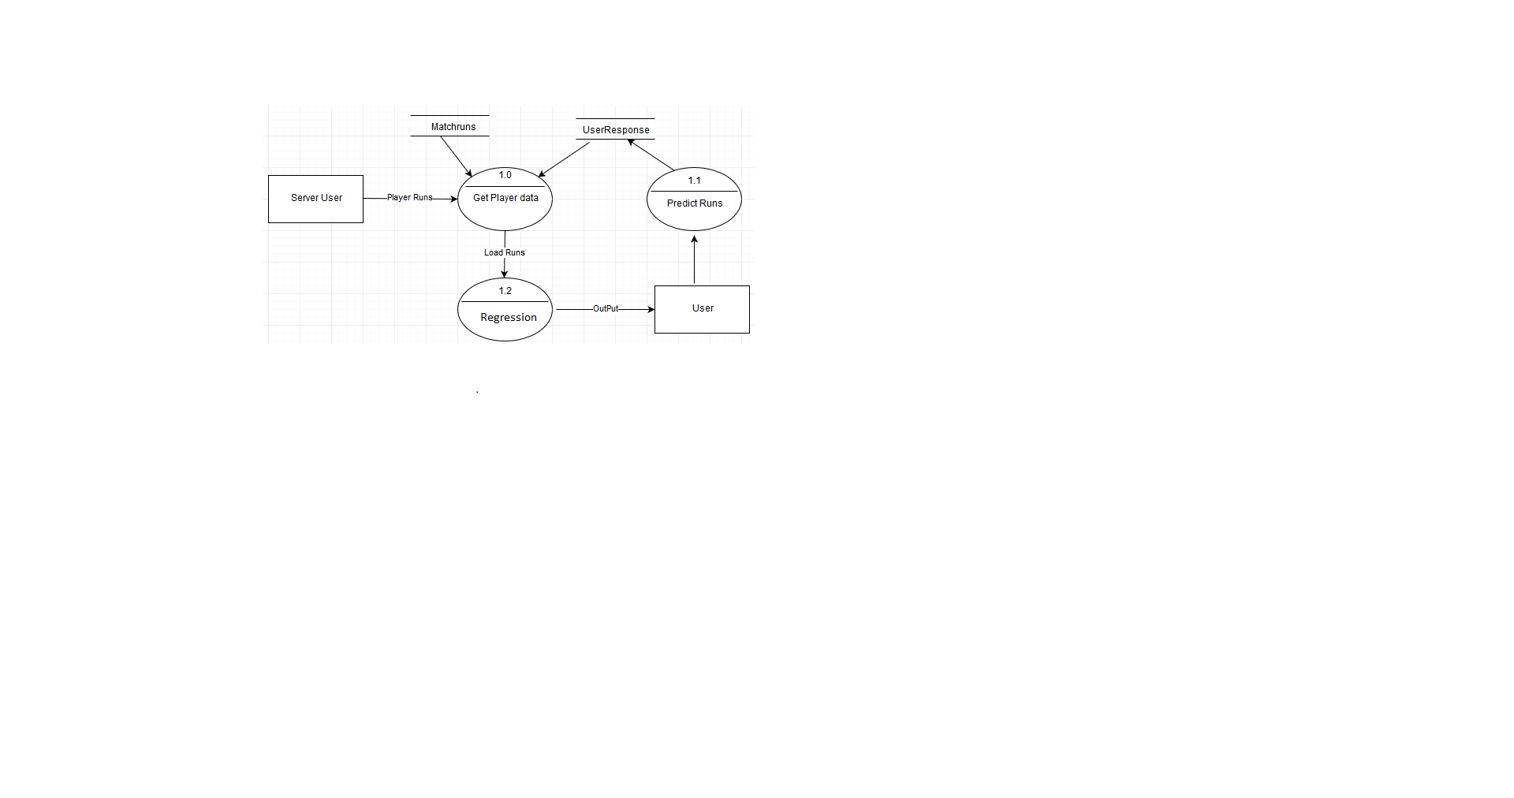

Figure 1.1

3.1.2Specification Document / Uml diagram of all modules

The **Unified Modeling Language (UML)**is a language used in the field of software engineering that represent the components of the Object-Oriented Programming concepts. It is the general way to define the whole software architecture or structure. In Object-Oriented Programming, we solve and interact with complex algorithms by considering themselves as objects or entities. These objects can be anything. It can be the bank or a bank manager too. The object can be a vehicle, animal, machine, etc. The thing is how we interact and manipulate them that they can perform tasks and they should. The tasks can be interacting with other objects, transferring data from one object to another, manipulating other objects, etc.

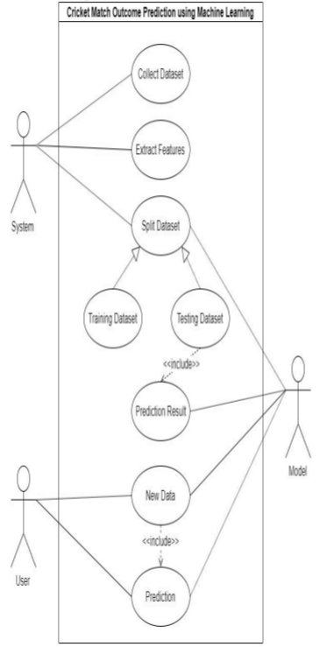

Use case diagram

The single software could have hundreds or even thousands of objects. So, **UML** provides us a way to represent and track those objects in a diagram to become a blueprint of our software architecture. A Use Case Diagram can be regarded as a good starting point for discussing project key actors and processes without going into too many implementation details. This UML diagrams is also the most popular type of the Behavioral UML diagram category, and is used to analyze the functionality (the use cases) and the interactions with different types of agents (actors) of a system. This UML diagram is the blueprint of the software architecture .

3.2 User Interface Design (TBD)

3.3 Database Design / ER Diagrams

An Entity Relationship (ER) Diagram is a type of flowchart that illustrates how “entities” such as people, objects or concepts relate to each other within a system. ER Diagrams are most often used to design or debug relational databases in the fields of software engineering, business information systems, education and research. The ER diagram is the pictorial representation of the objects and their relationships. The ER diagram is the subclass of the UML diagram. It is used to design and implement the databases. They use a defined set of symbols such as rectangles, diamonds, ovals and connecting lines to depict the interconnectedness of entities, relationships and their attributes. They mirror grammatical structure, with entities as nouns and relationships as verbs. This E-R diagram is the representation of various entities and relationships and their attributes.

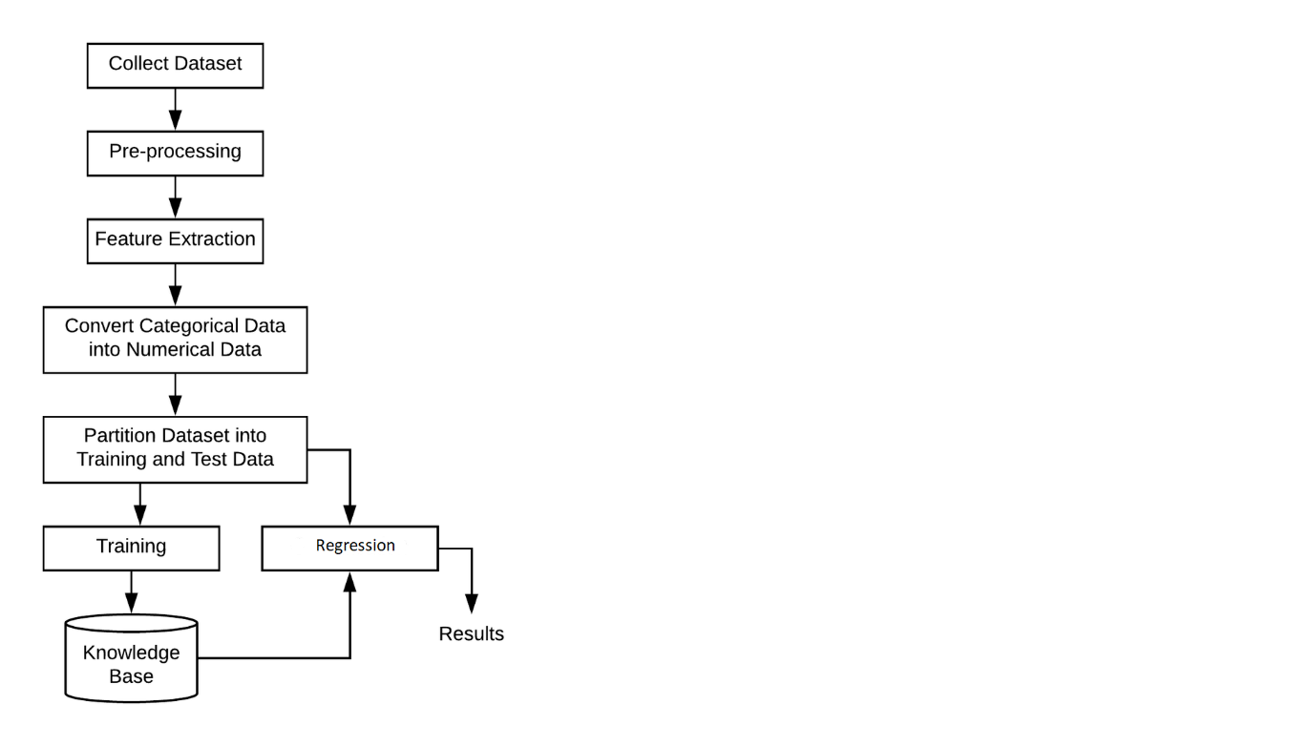

Figure 1.2

3.4 Process Diagram

Process diagrams, called “flow diagrams” by TOGAF, are used to model the sequence of activities within a process. Flow diagrams represent process participants, activity sequences, information exchanged during a process, and trigger events. A process diagram consists of activities, events, and gateways, which a sequence flow puts in a flow sequence. The following process diagram describes the overall processes includes in this architecture.



**4 Performance Evaluation .**

**5 Conclusion**

**References (TNR 16)**

[1] [IPL _Data_Set | Kaggle](https://www.kaggle.com/ramjidoolla/ipl-data-set) (12/29/2021)

[2] [Duff & Phelps Launches IPL Brand Valuation Report 2019 | Duff & Phelps (duffandphelps.com)](https://www.duffandphelps.com/about-us/news/ipl-brand-valuation-report-2019)(12/29/2021)

[3] [IPL Advertising: All You Need To Know About The Game of Revenue (kreedon.com)](https://www.kreedon.com/ipl-advertising-all-you-need-to-know/) (5/12/2021)

[4] [Sport Analytics | A data-driven approach to sport business and managem (taylorfrancis.com)](https://www.taylorfrancis.com/books/edit/10.4324/9781315619088/sport-analytics-gil-fried-ceyda-mumcu) (5/12/2021)

[5] [Sport Analytics | A data-driven approach to sport business and managem (taylorfrancis.com)](https://www.taylorfrancis.com/books/edit/10.4324/9781315619088/sport-analytics-gil-fried-ceyda-mumcu) (5/12/2021)

[6] [Survey on deep learning with class imbalance | Journal of Big Data | Full Text (springeropen.com)](https://journalofbigdata.springeropen.com/articles/10.1186/s40537-019-0192-5) (14/1/2022)

**Note : -1) Mention the date & time when you have access the website.**

**ACKNOWLEDGEMENT**

We would like to place on record our deep sense of gratitude to Prof. S. B. Kalyankar, HOD-Dept. of Computer Science and Engineering, Deogiri Institute of Engineering and management Studies Aurangabad, for his generous guidance, help and useful suggestions.

We express our sincere gratitude to Prof. Vijay Kolte , Dept. of Computer Science and Engineering, Deogiri Institute of Engineering and management Studies Aurangabad, for his stimulating guidance, continuous encouragement and supervision throughout the course of present work.

We are extremely thankful to Dr. Ulhas Shiurkar, Director, Deogiri Institute of Engineering, and management Studies Aurangabad, for providing me infrastructural facilities to work in, without which this work would not have been possible.

**Signature(s) of Students**

Abhishek Jaju 

Pradeep Maku C:\Users\PRADEEP\Downloads\sign1.jpeg

Vivek Soddy 